Do You

We’d be absolutely thrilled if you wrote something nice about us on Yelp!

It’s as easy as 1-2-3 on your smartphone:

Step 1:  Open the Yelp app  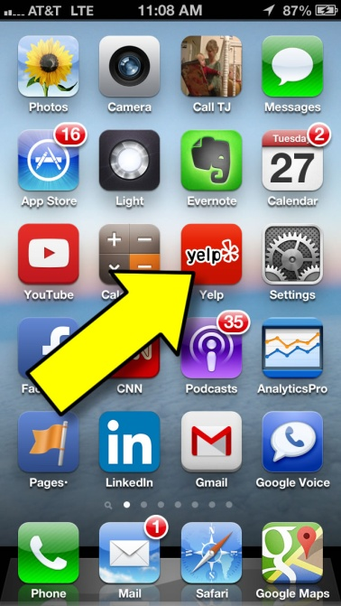 | Step 2:  Search for our agency  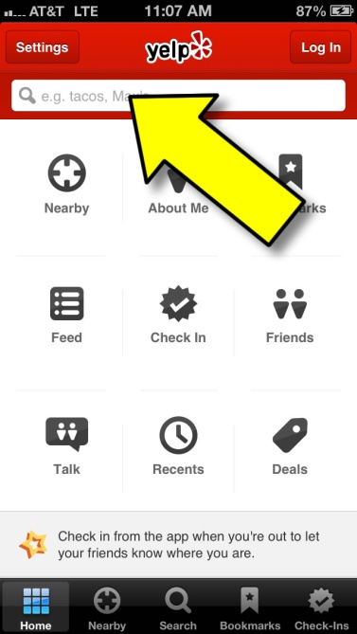 | Step 3:  Click “Add Review”  